Trade Name Intelligence Service — Spec
Oct 5, 2026 · @Enugala Venkata Ramana

1. Overview
The Trade Name Intelligence Service is a new Python service that replaces the current AI integration with one LLM-assisted pipeline that validates Arabic/English trade names, finds similar names, suggests alternatives and briefs reviewers. Final decisions stay deterministic and auditable; the LLM can only add restrictions or route a name to human review.
In scope
- Validation of new, edited, renewed, branch (outside UAQ) and legal-form-amended trade names
- Similarity search, suggestions, transliteration checks and keyword search
- Reviewer copilot for the DED online review and SSP committee steps
- Registry-to-index sync, word-list (lexicon) management, audit and evaluation
Out of scope
- Fees, periods, renewal eligibility, BPM workflow and certificate generation (unchanged)
- Front-end redesign: existing endpoints and response fields are kept
Goals
- Never auto-approve a name when an AI component is unavailable (fail closed)
- Validation p95 under 3 s; suggestions p95 under 5 s
- Every rejection explained in Arabic and English with a suggested fix
- Agreement with past reviewer decisions measured before any feature goes live

2. Requirements
Functional requirements F1–F22 are carried over from today's business rules; N1–N9 are quality requirements; E1–E8 are new capabilities.

2.1 Functional
ID | Requirement
F1 | Every trade name has an Arabic and an English form
F2 | Exact-duplicate check against active names (not released, not expired, not draft), ignoring case and spaces, excluding the record being edited
F3 | Similarity check against existing names
F4 | Word checks: prohibited, profanity, unfriendly, special words, divine names, location names, family names
F5 | Parse input into core name, activity words and legal form
F6 | Arabic ↔ English transliteration
F7 | Validate an edited transliteration against the original
F8 | Up to 10 distinct, unreserved suggestions combining name + activity; legal form shown when the legal form requires it
F9 | Complementary suggestions (name + related activity wording)
F10 | Outside-UAQ branches get the suffix "Umm Al Quwain Branch" / "فرع أم القيوين"; conflicts checked with the suffix
F11 | Legal-form amendment swaps or removes the old legal-form wording in both languages, then checks conflicts
F12 | If the name is unchanged and only legal form or branch status changes, skip word checks but keep the similarity check
F13 | Online (applicant) and Walk-in (employee) channels
F14 | Messages follow the lang header; the failing language's result is shown
F15 | Name index stays in sync on insert, edit, release and delete, with activity category and codes
F16 | Per-capability feature flags
F17 | English names returned in upper case
F18 | Reserved names are never suggested
F19 | Keyword search over trade names
F20 | Support reviewer actions: approve, reject, return, SSP committee
F21 | Rejected or released names become available again
F22 | Search keyword stored in both languages

2.2 Non-functional
ID | Requirement
N1 | Fail closed: an AI outage never approves a name
N2 | Validation p95 < 3 s; suggestions p95 < 5 s
N3 | Every AI decision auditable, linked to the real request ID
N4 | Every flag explained in Arabic and English
N5 | Self-hosted open-source LLM; no data leaves DED infrastructure
N6 | Prompt-injection resistant; the trade name is untrusted input
N7 | Quality measured against past reviewer decisions
N8 | Bounded, predictable LLM cost
N9 | Existing endpoints and response fields unchanged (additive only)

2.3 New capabilities
ID | Capability
E1 | Catch misspellings, leetspeak, Arabizi and cross-language offensive meanings
E2 | Phonetic and semantic matching across scripts (Noor = Nour = النور)
E3 | Check the name fits the chosen activity category
E4 | Explain rejections and propose fixes
E5 | Reviewer brief and draft comments
E6 | Suggest an activity category from the name
E7 | LLM-proposed lexicon variants, approved by a human
E8 | Fuzzy, cross-language search

3. Architecture
Each validation request runs through six stages; the LLM is used in stages ④ and ⑥ only, and stage ⑤ makes the final call.
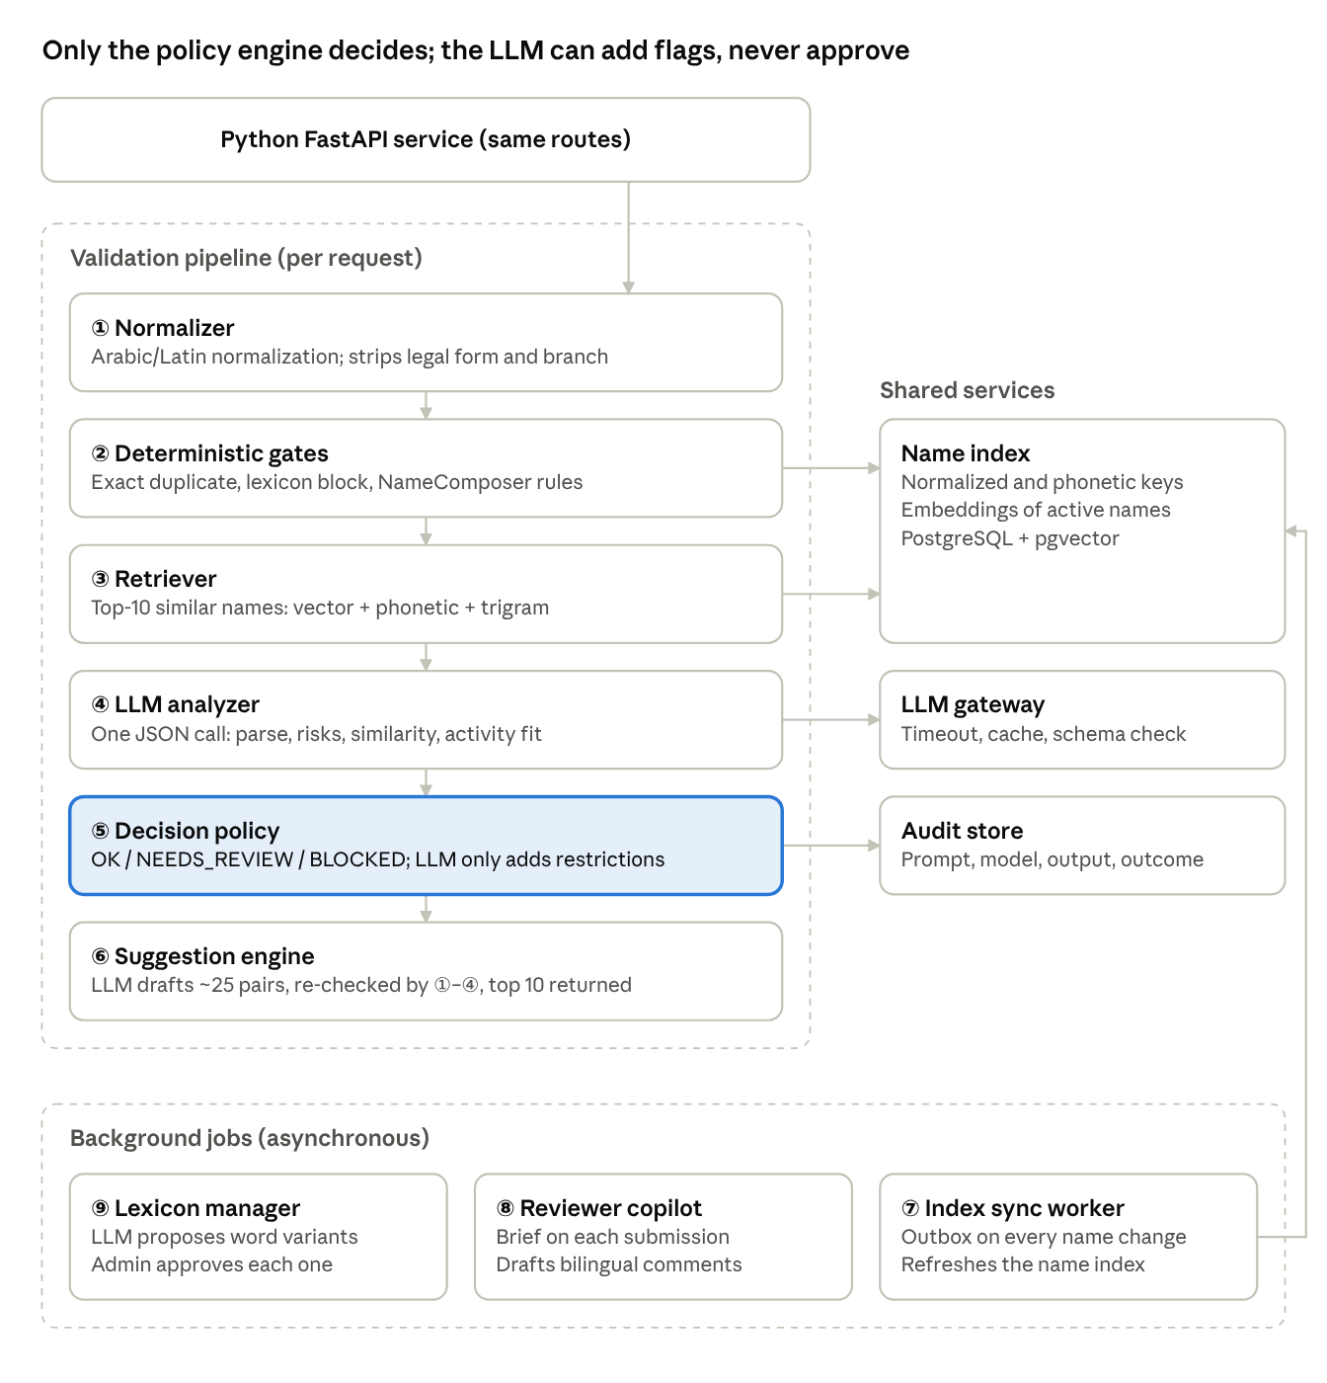
architecture · 6 pipeline stages, 3 shared services, 3 background jobs
Stages ①–③ need no LLM, so duplicate and word-list checks still run during an LLM outage. Background jobs keep the name index current and support reviewers and admins.
Component | Responsibility | Uses LLM
① Normalizer | Arabic: remove diacritics and tatweel, unify alef forms, ة→ه, ى→ي. English: NFKC + case-fold. Strip legal-form and branch tokens by exact match | No
② Deterministic gates | Exact duplicate on normalized keys; lexicon match with variants and edit distance; NameComposer applies branch suffix, legal-form display and the F12 exemption | No
③ Retriever | Hybrid top-10 similar active names: multilingual embeddings, cross-script phonetic key, trigrams | Embeddings only
④ LLM analyzer | One structured call returning parse, risks, similarity verdicts, transliteration check and activity fit (section 4.2) | Yes
⑤ Decision policy | Combines all signals into OK / NEEDS_REVIEW / BLOCKED (section 4.1) | No
⑥ Suggestion engine | LLM drafts ~25 bilingual pairs; batch re-check through ①–②; batch LLM screen; one reservation query; rank and return top 10; template fallback | Yes
⑦ Index sync worker | Outbox row written in the same transaction as each name change; computes keys and embeddings; nightly reconciliation | Embeddings only
⑧ Reviewer copilot | Brief per submission: flags, top-5 similar names, transliteration and fit verdicts, recommendation; drafts AdminComments | Yes
⑨ Lexicon manager | Admin UI for word lists; LLM proposes variants (spellings, Arabizi, plurals); a human approves each | Yes
LLM gateway | Timeouts, retry, circuit breaker, cache, schema validation, audit write | Wraps all LLM calls

3.1 Technology stack (Python)
The service is built from scratch in Python 3.12 with async I/O throughout; every component runs on DED infrastructure.
Layer | Choice
API | FastAPI + Pydantic v2 models; served by Uvicorn behind the existing gateway
Auth | Validates the JWTs issued by the current identity provider; channel (Online / Walk-in) read from the token
Data access | SQLAlchemy 2.0 (async) + asyncpg; Alembic migrations
Database | PostgreSQL with pgvector (embeddings) and pg_trgm (trigram similarity)
Arabic text | Custom normalizer module; CAMeL Tools for morphology and transliteration fallback
Fuzzy matching | RapidFuzz (edit distance); custom cross-script phonetic key
LLM serving | vLLM hosting open-source instruction models with strong Arabic support; guided JSON decoding against the Pydantic schema
Embeddings | Open-source multilingual embedding model served by Text Embeddings Inference
Background jobs | arq workers on Redis for outbox sync, reviewer briefs and lexicon proposals
Cache | Redis
Observability | OpenTelemetry tracing, Prometheus metrics, structlog JSON logs
Testing and eval | pytest unit and integration tests; evaluation harness runs the gold set in CI
Packaging and deploy | uv for dependencies; Docker images on DED's container platform
Suggested package layout: api/ (routes), pipeline/ (stages ①–⑥), llm/ (client, prompts, schemas), index/ (pgvector repository, sync worker), copilot/, lexicon/, audit/, eval/.

4. Decision policy and LLM contract
The policy engine, not the LLM, produces the final outcome: OK, NEEDS_REVIEW or BLOCKED. The LLM can add flags but never lift a hard block.

4.1 Decision rules
Signal | Outcome
Hard gate hit (exact duplicate, lexicon block) | BLOCKED, whatever the LLM says
LLM risk with severity block and confidence ≥ threshold | BLOCKED
LLM risk review, low confidence, transliteration mismatch or poor activity fit | NEEDS_REVIEW (applicant may submit; reviewer sees flags)
LLM unavailable or timed out | Hard gates still run; best outcome is NEEDS_REVIEW
No flags | OK
The F12 exemption (unchanged name) is applied here: word checks are skipped, similarity is kept. Thresholds live in configuration and are tuned during shadow mode.

4.2 LLM analyzer output
One call per validation, temperature 0, output enforced by JSON schema. Input is only the name pair, activity category, legal form, channel and the top-10 similar names.
{
"parse": { "core_ar": "", "core_en": "", "activity_words": [], "legal_form": null, "branch": false },
"transliteration": { "consistent": true, "confidence": 0.0, "expected_en": "", "expected_ar": "" },
"risks": [{
"category": "prohibited|profanity|unfriendly|special|divine_name|location|family_name|impersonation|misleading",
"language": "ar|en|both", "span": "", "severity": "block|review|info", "confidence": 0.0,
"reason_en": "", "reason_ar": "", "fix_en": "", "fix_ar": ""
}],
"similar": [{ "registry_id": 0, "confusingly_similar": true, "reason_en": "", "reason_ar": "" }],
"activity_fit": { "fits": true, "suggested_category_code": null, "reason_en": "", "reason_ar": "" }
}

4.3 Prompt rules
- The trade name is wrapped in <trade_name> tags and declared as data, never instructions
- System prompt holds DED naming rules and examples from past reviewer decisions; it is cached
- Prompts are versioned; the version is stored with every audit record
- Output that fails schema validation is treated as "LLM unavailable"

5. Data model, APIs and feature flags
Six new tables support the service; existing endpoints keep their contracts and gain only optional fields.

5.1 New tables
Table | Key columns | Purpose
TradeNameIndex | Id, NormalizedAr, NormalizedEn, PhoneticKey, EmbeddingAr, EmbeddingEn, CategoryId, Status, ExpiryDate | Fast exact, phonetic and vector lookup of active names (PostgreSQL + pgvector)
Lexicon | Term, NormalizedTerm, Category, Lang, Severity, Variants, ApprovedBy | Managed word lists for F4; changes approved by DED
NameIndexOutbox | Id, TradeNameId, Operation, CreatedOn, ProcessedOn | Reliable index sync (F15)
AiDecisionAudit | RequestId, Channel, InputHash, PromptVersion, ModelId, RawOutput, Outcome, LatencyMs, Tokens | Audit trail (N3)
ReviewerBrief | RequestId, BriefJson, GeneratedOn, ReviewerDecision | Copilot output and feedback (E5, N7)
PromptVersion | Id, Name, Text, CreatedOn, Active | Versioned prompts

5.2 Endpoints
Endpoint | Status | Change
POST TradeName/ValidateWithSuggestion | Existing | Adds decision, reasons[], similarNames[], activityFit
GET TradeName/IsTradeNameExist | Existing | Uses normalized keys
GET TradeName/Search | Existing | Hybrid retrieval
POST TradeName/CheckTransliteration | New | F7
POST TradeName/SuggestCategory | New | E6
GET TradeName/ReviewerBrief/{requestId} | New | E5
POST Admin/Lexicon/Proposals | New | E7, approve or reject variants
The existing validation fields (Prohibted, Profanity, Unfriendly, Special, AllahNames, LocationNames, FamilyNames, Similarity) are still filled, so current front ends work unchanged.

5.3 Feature flags
Each flag takes Off, Shadow (run and log, no effect on outcome) or On.
Flag | Controls
Ai.Analyzer | LLM semantic validation
Ai.Suggestions | LLM suggestion generation
Ai.ReviewerBrief | Reviewer copilot
Ai.Search | Hybrid semantic search
Ai.LexiconProposals | LLM lexicon variants

6. Security, operations and evaluation
The LLM sits behind a gateway that enforces timeouts, caching, redaction and audit; quality is gated by an evaluation set built from past reviewer decisions.

6.1 Security and privacy
- Only the name pair, activity category and legal form leave the service; no applicant names, IDs, emails or phone numbers
- Self-hosted open-source LLM and embedding models inside DED infrastructure; no external API calls
- Trade name treated as untrusted data in prompts; outputs validated against the schema before use
- Policy engine cannot be overridden by model output

6.2 LLM gateway
- Async LlmClient protocol: analyze, generate_suggestions, screen_batch, brief; calls the self-hosted vLLM endpoint (OpenAI-compatible API)
- 2.5 s timeout on the validation path, one retry on transient errors, circuit breaker
- Response cache keyed by normalized pair + category + legal form + prompt version, 24 h TTL
- Model tiers, all open-source and self-hosted: a larger instruction model for analysis and reviewer briefs, a smaller one for suggestion generation and screening, and a multilingual embedding model for the name index

6.3 Observability
- Metrics: latency per stage, LLM error and timeout rate, outcome mix (OK / NEEDS_REVIEW / BLOCKED), cache hit rate, tokens per request
- Alerts when the LLM error rate or the NEEDS_REVIEW share spikes

6.4 Evaluation
- Gold set from past approve/reject decisions and reviewer notes, labelled and owned by DED, plus adversarial cases (Arabizi, mixed scripts, injection attempts)
- Runs in CI on every prompt or model change
- Tracked: precision and recall per F4 category, agreement with reviewers, false-block rate
- A feature moves from Shadow to On only after it meets agreed thresholds

7. Traceability and rollout
Every requirement in section 2 maps to at least one component; component numbers refer to section 3.

7.1 Traceability matrix
Req | Fulfilled by
F1 | ① normalizes both forms; ④ analyzes the pair together
F2 | ① normalized keys + ② indexed lookup with one shared filter
F3 | ③ hybrid retrieval + ④ confusing-similarity judgement
F4 | ② lexicon (hard) + ④ semantic layer + ⑨ lexicon upkeep
F5 | ① dictionary stripping + ④ parse
F6 | ④ transliteration + deterministic fallback library
F7 | CheckTransliteration endpoint backed by ④
F8 | ⑥ generate → filter → rank
F9 | ⑥ complementary patterns in the generation constraints
F10 | NameComposer suffix rule + suffix-aware matching in ②
F11 | NameComposer token swap + ② conflict check
F12 | ⑤ policy exemption rule
F13 | Channel passed in request context and stored in audit
F14 | ⑤ picks the failing language; reasons always bilingual
F15 | ⑦ outbox worker + nightly reconciliation
F16 | Per-capability Off / Shadow / On flags
F17 | ⑥ final formatting
F18 | ⑥ set-based reservation check
F19 | ③ hybrid retriever behind Search
F20 | ⑧ reviewer brief + draft comments
F21 | Status filter in ② + ⑦ removes released names from the index
F22 | Keyword transliteration via ④ with fallback
N1 | ⑤ outage → NEEDS_REVIEW; hard gates need no LLM
N2 | Single analyzer call, parallel retrieval, cache, 2.5 s timeout
N3 | AiDecisionAudit with real request IDs
N4 | Bilingual reason and fix on every flag
N5 | Self-hosted model; only name and category sent
N6 | Delimited input, schema-enforced output, policy cannot be overridden
N7 | Gold set, CI evaluation, shadow mode
N8 | Model tiers, caching, batched screening
N9 | Same routes and fields, additive changes only
E1 | ④ semantic risk checks
E2 | ③ phonetic + embedding matching
E3 | ④ activity_fit
E4 | ④ fix_en / fix_ar
E5 | ⑧ reviewer copilot
E6 | SuggestCategory endpoint backed by ④
E7 | ⑨ lexicon manager
E8 | ③ hybrid search

7.2 Rollout
- Foundation — normalizer, deterministic gates, NameComposer, name index with outbox, audit table. Exit: all F-requirements pass regression with AI flags Off.
- Analyzer in Shadow — LLM runs and logs beside reviewer decisions. Exit: agreed precision, recall and false-block thresholds met on the gold set and live traffic.
- Analyzer On — decision policy and bilingual explanations live.
- Suggestions and search — LLM suggestion engine and hybrid search, each through Shadow first.
- Reviewer copilot, lexicon manager, category suggestion.

7.3 Decisions
- Implementation: a new service written entirely in Python (section 3.1); it exposes the same API routes so existing front ends keep working
- LLM hosting: self-hosted open-source models inside DED infrastructure; no trade-name data leaves the environment
- Vector store: PostgreSQL with pgvector for the name index
- Ownership: DED owns lexicon approvals and the gold-set labels

